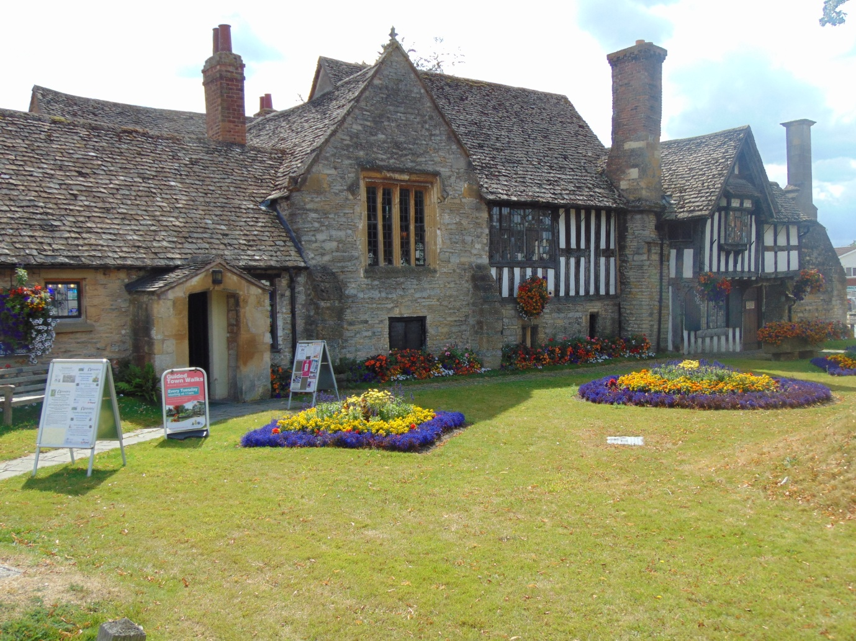

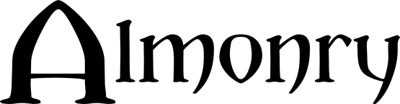

Abbey Gate
Evesham
Worcestershire
WR11 4BQ
01386 446944
tic@almonry.ndo.co.uk
www.almonryevesham.org

Collections Development Policy

2017-2022

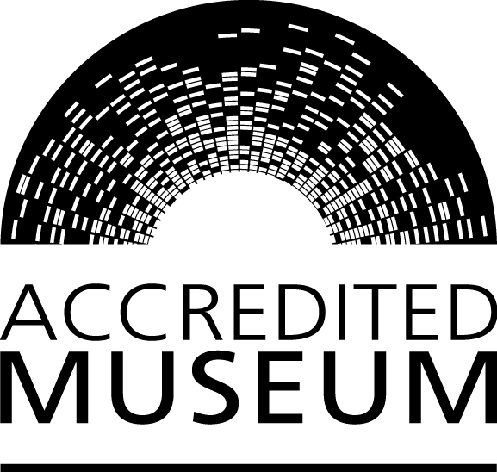
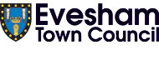

Name of museum: Almonry Museum

Name of governing body: Evesham Town Council

Date on which this policy was approved by governing body: 13th November 2017 (amended 11th February 2019)

Policy review procedure:

The collections development policy will be published and reviewed from time to time, at least once every five years.

Date at which this policy is due for review: 5 yrs from date of approval (tbc)

Arts Council England will be notified of any changes to the collections development policy, and the implications of any such changes for the future of collections.

- Relationship to other relevant policies/plans of the organisation:

  - The museum’s statement of purpose is:
The Almonry Museum represents and reflects the historical, social, political and cultural evolution of Evesham and the surrounding area, known as the Vale of Evesham. It serves to represent the stories of the people and communities that helped to shape the town and Vale and to engage the local community and visitors to Evesham with those stories.

  - The governing body will ensure that both acquisition and disposal are carried out openly and with transparency.

  - By definition, the museum has a long-term purpose and holds collections in trust for the benefit of the public in relation to its stated objectives. The governing body therefore accepts the principle that sound curatorial reasons must be established before consideration is given to any acquisition to the collection, or the disposal of any items in the museum’s collection.

  - Acquisitions outside the current stated policy will only be made in exceptional circumstances.

  - The museum recognises its responsibility, when acquiring additions to its collections, to ensure that care of collections, documentation arrangements and use of collections will meet the requirements of the Museum Accreditation Standard. This includes using SPECTRUM primary procedures for collections management. It will take into account limitations on collecting imposed by such factors as staffing, storage and care of collection arrangements.

  - The museum will undertake due diligence and make every effort not to acquire, whether by purchase, gift, bequest or exchange, any object or specimen unless the governing body or responsible officer is satisfied that the museum can acquire a valid title to the item in question.

  - The museum will not undertake disposal motivated principally by financial reasons

- History of the collections

The museum opened in 1957 when Evesham Borough Council agreed to allow the Vale of Evesham Historical Society (VEHS) to display their collection of objects in 2 rooms of the Almonry building. The Borough Council provided a live in caretaker and provided all care and maintenance of the building while VEHS acted as Honorary Curators for the collection. Over the last 60 years the collection has grown, covering many collecting areas form archaeology to numismatics and social history. In 1997 Evesham Town Council were formally recognised as the governing body of the museum, they adopted the Spectrum Standard Object Entry Forms and established ownership of the collection from this point forward.
Key acquisitions made by the Borough and later Town Council include:
- First Edition Matthew Bible 1537 which includes a handwritten eyewitness account of the dissolution of Evesham Abbey (purchased at auction 1974 with V&A Purchase Grant)
- Anglo Saxon Burial from Bennet’s Hill near Evesham (purchased at auction in 2000 with V&A Purchase grant)
- Evesham Town Charter 1604, the original Town Charter signed by Prince Henry son of James I
- Evesham Town ceremonial maces dating from 1604

At any given time the collection at the Almonry is a mix of objects owned by the Town Council and items on loan from individuals, other museums and groups and/or organisations. The collection reflects life in Evesham and the Vale from Prehistory to mid-twentieth century. Due to the nature of historic ad hoc collecting there are many duplicates and objects that fall out of the scope of this policy.
Following a recent legal investigation it has become apparent that a large proportion of the museum collection belongs to the VEHS without any formal loan agreement between them and the Almonry Museum. There is a programme in place to return all objects to VEHS. This activity will remove many duplicates and many objects that fall outside the scope of this collecting policy.
Once the VEHS collection has been returned, Almonry staff will begin to look at the museum collection to further identify areas for development and collecting and will undertake a rationalisation review of the collection.

- An overview of current collections

The objects in the collection can be categorised as follows:
- Archaeology – prehistory, Bronze Age, Iron Age, Roman, Medieval, Post Medieval. Significant objects include Palaeolithic hand tools, Bronze Age hand tools, Iron Age and Roman beads
- Numismatics – predominantly Roman from the Bredon Hill area with later additions
- Militaria – Costume, medals and personal effects relating to individuals from Evesham and the Vale
- Costume and textiles – a small range of costume and textiles predominantly personal effects
- Books- including histories of Evesham and the Vale, personal diaries, seed catalogues
- Documents- archival material including maps, plans, letters, conveyances, newspapers
- Photographs and postcards – small collection of photographs, some that supplement object donations e.g. photographs of individuals wearing costume
- Agriculture and horticulture – a collection of objects that reflect the agricultural and horticultural development of the Vale consisting of tools, machinery, baskets and ephemera
- Social History – Collections range from Victoriana and kitchenalia , civic development
- Industries and professions- Local police, civic roles
- Handling and education collections

Our handling and education collections are not accessioned but are listed. Our handling collections are a mix of reproduction and original objects. Not all of the original objects are geographically correct i.e. within the Vale boundary, but are used to help illustrate time periods or subjects.

Our collection meets our statement of purpose through reflecting the changing landscape of the Vale and by representing the human habitation of Evesham and the Vale.

- Themes and priorities for future collecting

The main priority for future collecting is to represent and reflect the changing communities that have influenced Evesham and the Vale from the mid-twentieth century to the present, an area that is not currently covered. Through our rationalisation project we will identify gaps in our collection and will actively seek to collect objects, oral histories and ephemera that fill those gaps. We will continue to monitor all unsolicited potential donations, taking each one on its own merit and consider size, quality, relevance and storage conditions. We will also consider whether any potential donation would be better placed within our accessioned collection or within our handling collection.

- Themes and priorities for rationalisation and disposal

  - The museum recognises that the principles on which priorities for rationalisation and disposal are determined will be through a formal review process that identifies which collections are included and excluded from the review. The outcome of review and any subsequent rationalisation will not reduce the quality or significance of the collection and will result in a more useable, well managed collection.

  - The procedures used will meet professional standards. The process will be documented, open and transparent. There will be clear communication with key stakeholders about the outcomes and the process.

We will be undertaking a process of rationalisation following the return of the VEHS collection. The Almonry Manager supported by the Almonry team will develop a framework for rationalisation based around agreed themes for collecting. Any disposals will be made in accordance with the framework as stated below (section 16).

- Legal and ethical framework for acquisition and disposal of items

  - The museum recognises its responsibility to work within the parameters of the Museum Association Code of Ethics when considering acquisition and disposal.

- Collecting policies of other museums

  - The museum will take account of the collecting policies of other museums and other organisations collecting in the same or related areas or subject fields. It will consult with these organisations where conflicts of interest may arise or to define areas of specialism, in order to avoid unnecessary duplication and waste of resources.

  - Specific reference is made to the following museum(s)/organisation(s):

Museums Worcestershire
Broadway Museum

- Archival holdings

The Almonry holds various archival records including conveyances, indentures, letters, diaries, photographs and maps.

- Acquisition

  - The policy for agreeing acquisitions is:

Authorisation for acquisition lies with the Almonry Manager. When considering an acquisition the Manager will consult with Almonry Staff and will exercise due diligence in all aspects of acquisition. The Almonry will not usually acquire items through purchase unless they are of particular significance. In the case of small value purchases the Manager will consult with the Town Clerk and if necessary will approach the Town Council for permission to purchase the item. In the case of large value purchases (e.g. treasure at auction) the Manager will inform the Town Council of their intention to purchase and will raise funds either by fundraising activities or through grants.

When considering loans, objects will only be borrowed if they have a clear link to either the overall collecting policy or for specific exhibitions and/or events. Loan periods shall not extend beyond 3 years maximum. When considering loans the size, condition and care of the object/collection will be taken into account.

Exceptions to this are where objects are under historic long term or ‘permanent’ loan agreements e.g. the Abbey Chair, Sevastopol Cannon

  - The museum will not acquire any object or specimen unless it is satisfied that the object or specimen has not been acquired in, or exported from, its country of origin (or any intermediate country in which it may have been legally owned) in violation of that country’s laws. (For the purposes of this paragraph ‘country of origin’ includes the United Kingdom).

  - In accordance with the provisions of the UNESCO 1970 Convention on the Means of Prohibiting and Preventing the Illicit Import, Export and Transfer of Ownership of Cultural Property, which the UK ratified with effect from November 1 2002, and the Dealing in Cultural Objects (Offences) Act 2003, the museum will reject any items that have been illicitly traded. The governing body will be guided by the national guidance on the responsible acquisition of cultural property issued by the Department for Culture, Media and Sport in 2005.

- Human remains

  - As the museum holds or intends to acquire human remains from any period, it will follow the procedures in the ‘Guidance for the care of human remains in museums’ issued by DCMS in 2005.

- Biological and geological material

  - So far as biological and geological material is concerned, the museum will not acquire by any direct or indirect means any specimen that has been collected, sold or otherwise transferred in contravention of any national or international wildlife protection or natural history conservation law or treaty of the United Kingdom or any other country, except with the express consent of an appropriate outside authority.

- Archaeological material

  - The museum will not acquire archaeological material (including excavated ceramics) in any case where the governing body or responsible officer has any suspicion that the circumstances of their recovery involved a failure to follow the appropriate legal procedures.

  - In England, Wales and Northern Ireland the procedures include reporting finds to the landowner or occupier of the land and to the proper authorities in the case of possible treasure (i.e. the Coroner for Treasure) as set out in the Treasure Act 1996 (as amended by the Coroners & Justice Act 2009).

- Exceptions

  - Any exceptions to the above clauses will only be because the museum is:

  - acting as an externally approved repository of last resort for material of local (UK) origin

  - acting with the permission of authorities with the requisite jurisdiction in the country of origin

In these cases the museum will be open and transparent in the way it makes decisions and will act only with the express consent of an appropriate outside authority. The museum will document when these exceptions occur.

- Spoliation

  - The museum will use the statement of principles ‘Spoliation of Works of Art during the Nazi, Holocaust and World War II period’, issued for non-national museums in 1999 by the Museums and Galleries Commission.

- The Repatriation and Restitution of objects and human remains

  - The museum’s governing body, acting on the advice of the museum’s professional staff, if any, may take a decision to return human remains (unless covered by the ‘Guidance for the care of human remains in museums’ issued by DCMS in 2005) , objects or specimens to a country or people of origin. The museum will take such decisions on a case by case basis; within its legal position and taking into account all ethical implications and available guidance. This will mean that the procedures described in 16.1-5 will be followed but the remaining procedures are not appropriate.

  - The disposal of human remains from museums in England, Northern Ireland and Wales will follow the procedures in the ‘Guidance for the care of human remains in museums’.

- Disposal procedures

  - All disposals will be undertaken with reference to the SPECTRUM Primary Procedures on disposal.

  - The governing body will confirm that it is legally free to dispose of an item. Agreements on disposal made with donors will also be taken into account.

  - When disposal of a museum object is being considered, the museum will establish if it was acquired with the aid of an external funding organisation. In such cases, any conditions attached to the original grant will be followed. This may include repayment of the original grant and a proportion of the proceeds if the item is disposed of by sale.

  - When disposal is motivated by curatorial reasons the procedures outlined below will be followed and the method of disposal may be by gift, sale, exchange or as a last resort - destruction.

  - The decision to dispose of material from the collections will be taken by the governing body only after full consideration of the reasons for disposal. Other factors including public benefit, the implications for the museum’s collections and collections held by museums and other organisations collecting the same material or in related fields will be considered. Expert advice will be obtained and the views of stakeholders such as donors, researchers, local and source communities and others served by the museum will also be sought.

  - A decision to dispose of a specimen or object, whether by gift, exchange, sale or destruction (in the case of an item too badly damaged or deteriorated to be of any use for the purposes of the collections or for reasons of health and safety), will be the responsibility of the governing body of the museum acting on the advice of professional curatorial staff, if any, and not of the curator or manager of the collection acting alone.

  - Once a decision to dispose of material in the collection has been taken, priority will be given to retaining it within the public domain. It will therefore be offered in the first instance, by gift or sale, directly to other Accredited Museums likely to be interested in its acquisition.

  - If the material is not acquired by any Accredited museum to which it was offered as a gift or for sale, then the museum community at large will be advised of the intention to dispose of the material normally through a notice on the MA’s Find an Object web listing service, an announcement in the Museums Association’s Museums Journal or in other specialist publications and websites (if appropriate).

  - The announcement relating to gift or sale will indicate the number and nature of specimens or objects involved, and the basis on which the material will be transferred to another institution. Preference will be given to expressions of interest from other Accredited Museums. A period of at least two months will be allowed for an interest in acquiring the material to be expressed. At the end of this period, if no expressions of interest have been received, the museum may consider disposing of the material to other interested individuals and organisations giving priority to organisations in the public domain.

  - Any monies received by the museum governing body from the disposal of items will be applied solely and directly for the benefit of the collections. This normally means the purchase of further acquisitions. In exceptional cases, improvements relating to the care of collections in order to meet or exceed Accreditation requirements relating to the risk of damage to and deterioration of the collections may be justifiable. Any monies received in compensation for the damage, loss or destruction of items will be applied in the same way. Advice on those cases where the monies are intended to be used for the care of collections will be sought from the Arts Council England.

  - The proceeds of a sale will be allocated so it can be demonstrated that they are spent in a manner compatible with the requirements of the Accreditation standard. Money must be restricted to the long-term sustainability, use and development of the collection.

  - Full records will be kept of all decisions on disposals and the items involved and proper arrangements made for the preservation and/or transfer, as appropriate, of the documentation relating to the items concerned, including photographic records where practicable in accordance with SPECTRUM Procedure on deaccession and disposal.

Disposal by exchange

  - The museum will not dispose of items by exchange.

Disposal by destruction

  - If it is not possible to dispose of an object through transfer or sale, the governing body may decide to destroy it.

  - It is acceptable to destroy material of low intrinsic significance (duplicate mass-produced articles or common specimens which lack significant provenance) where no alternative method of disposal can be found.

  - Destruction is also an acceptable method of disposal in cases where an object is in extremely poor condition, has high associated health and safety risks or is part of an approved destructive testing request identified in an organisation’s research policy.

  - Where necessary, specialist advice will be sought to establish the appropriate method of destruction. Health and safety risk assessments will be carried out by trained staff where required.

  - The destruction of objects should be witnessed by an appropriate member of the museum workforce. In circumstances where this is not possible, eg the destruction of controlled substances, a police certificate should be obtained and kept in the relevant object history file.

Version Control

Date | Change | Version | Name | Authorised date
04.02.2019 | Amendments to loan conditions (Section 2) | 2 | A Jayes
04.02.2019 | Addition of paragraph concerning loans (Section 9.1) | 2 | A Jayes

