Re-Imagining the Almonry

Application Pack

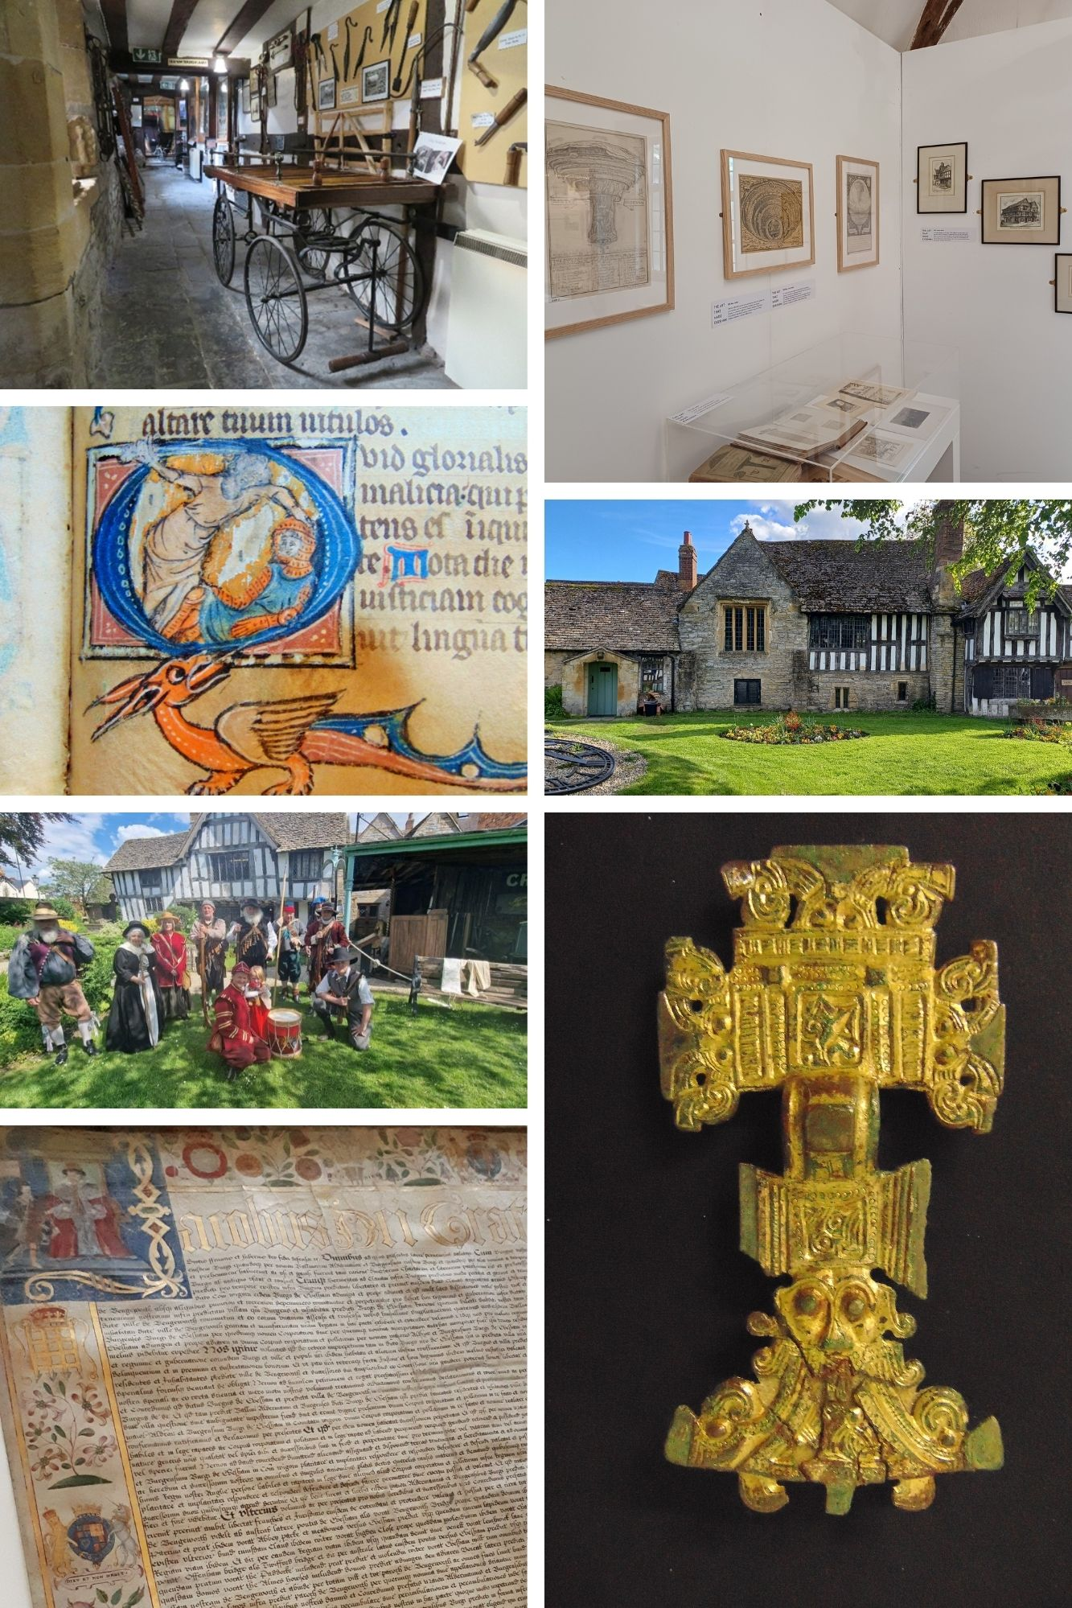
Project Curator

The Almonry
The Almonry is a late C14th monastic building, once part of Evesham Abbey. As the home of the Almoner, a Benedictine monk, the Almonry was a centre of caring and giving in the community.
The Almonry has been a home (up until the 1970s), but it has also been a tea room, offices and was the base for the Women’s Royal Voluntary Service during WWII. Its long history and variety of uses means the building has a story of its own to tell. Recent discoveries of historic wall paintings, a potential forgotten staircase and bricked up doorways and windows give hints to a wealth of stories about the building
The museum opened in 1957 with a collection amassed by the Vale of Evesham Historical Society. The collection reflected the diverse history of Evesham and the Vale from prehistoric archaeology to mid C20th social history. Today the collection still reflects the broad history of the town and wider Vale of Evesham.

Re-Imagining the Almonry Project
Re-Imagining The Almonry will bring about transformative change to this centuries old building. This National Lottery Heritage Fund project, alongside the concurrent Museum Estate Development Fund (MEND) funded Almonry Restoration Project, will not only secure the building’s future but will also see it saved for future generations resulting in its removal from the HARR. It will also see a re-Imagining of the visitor experience through:
- Developing and embedding an ethos based on the history of The Almonry as a place of ‘Caring, Sharing and Giving’, putting people at the heart of everything we do
- Developing and delivering a range of co-curated displays and exhibitions working with a wide variety of different audiences and communities in Evesham to tell the stories that matter to them
- Improving Collections Care with newly fitted out museum grade storage alongside improved environmental monitoring
- Undertaking collections cataloguing to minimum Inventory Standard
- Photographing collections, initially for internal cataloguing purposes but with a view to increasing access
- Installing new museum grade display cases with integral lighting and environmental monitoring
- New interpretations of collections, some co-curated, delivered using different media
- Developing a co-ordinated, planned and costed exhibition schedule
- Developing a re-interpreted garden space focused on the history of The Almonry and the horticultural heritage of the surrounding area with volunteers taking a leading role in the design, implementation and development of the spaces
- Integrating family friendly interpretation in the garden and museum and gallery activities that are designed in collaboration with users
- Creating flexible spaces within the existing building that are open to the community to continuously develop and tell stories
- Repurposing an existing outdoor shelter space into a modern flexible learning space that will cater for schools, community groups and organisations
- Working alongside a diverse range of community groups to broaden access, engagement and reach
- Redesigning the reception and shop space that will offer a welcoming space for visitors, maximising our ability to offer better Tourist Information and retail services
- Creating a new accessible entrance to the shop/museum reception
- Creating new branding that reflects the community ethos of The Almonry along with a new website that can host more and better information on our collections and stories
- Developing a new Forward Plan
- Producing a costed Maintenance Plan to complement the MEND Building Maintenance Plan to ensure that our museum objects and collections, alongside our building, are cared for appropriately
- Creating and implementing an Environmental Plan that will cover all our activities reducing our carbon footprint
- Developing the capacity of our team by utilising mentoring opportunities as part of the Development and Delivery Phase to ensure staff and volunteers are equipped with skills and knowledge moving forwards
- Increasing opportunities for volunteers to engage with the project on either short-term focused projects or longer-term opportunities such as the garden volunteers or as tour guides, school assistants, collections assistants and supporting them with training designed to give people the skill sets to benefit the work at The Almonry, as well as to support their own ambitions
You will be joining our small permanent team including the Manager, the Learning and Education Officer, the Retail Officer and the Family Engagement Assistant. Other new project posts include Community Co-Curation Lead Officer and Documentation and Collections Assistant. We will all be working together to bring this project to fruition along with external consultants, partners and funders.

Re-Imaging the Almonry Project Curator

F/T fixed term: up to 2 years with potential to extend dependent of funding

Salary: £38,049

Responsible to: Almonry Manager

Responsible for: Documentation Assistant, volunteers

Project Background
The Almonry recently received a grant of £2.1m to fund the Phase 1 ‘Almonry Restoration Project’ from Arts Council England MEND fund. The Almonry Restoration Project is a large-scale full repair and restoration of the building that will ensure its future and remove it from the HAR Register. This project is already underway and is due to complete in March 2027. The Almonry building is closed to the public and the team have moved to temporary premises to continue business activities.
The Almonry has received a further funding boost thanks to a Development Phase grant of £393,219 from The National Lottery Heritage Fund. Made possible thanks to National Lottery players, the money will support up to 2 years planning and activities to develop the Phase 2 ‘Re-Imagining the Almonry’ project that will transform the museum. Re-Imagining the Almonry will bring the museum into the community and will put the community at the heart of The Almonry, telling human stories, using our objects to make connections and engage emotions. The interpretation and displays will be completely new, planned in detail throughout this Development Phase. Through consultation and co-curation, we will begin a programme of meaningful inclusion, participation and representation. We will improve access to collections, collections care and display and create a learning space that can be used by community groups, schools and will be a source of income to benefit the future of The Almonry. We will create partnerships and connections with our partners and communities to ensure the project has a legacy and longevity that goes beyond the funding period. We will foster a Sense of Place, belonging and representation for our communities and have a stake in wider placemaking activities in the town.
Re-imagining The Almonry is essential to its future. Opening in 1957, the displays have remained relatively untouched since then and are now desperately in need of a refresh. More importantly, our stories need to be reinterpreted and involve more local people in creating narratives that engage and inspire.
During the Development Phase we will be recruiting a range of consultants and staff to achieve the ‘Re-imagining the Almonry’ project outcomes with the aim of submitting a Development Phase application in late 2027.

The Role
The Almonry Museum is seeking to appoint a Curator for the Heritage Fund supported Development Phase of the Re-Imagining the Almonry project.
The Almonry Museum is at pivotal point. Having received a £2.175m grant from the MEND fund, the museum was closed in September 2025 to begin major repair and restoration works.
While the repair works are being carried out, the Almonry team are embarking on Phase 2 of the project ‘Re-Imagining the Almonry’. Funded by the National Lottery Heritage Fund, Re-Imagining the Almonry will see a shift change in museum practice. Through the project we will embed our ethos of ‘Caring, Sharing and Giving’ by putting people at the heart of everything we do from redesigning and stocking the shop to developing and delivering exhibitions, events and learning activities.
The Almonry is a late C14th building, once home to the Almoner, a monk from the great Abbey at Evesham. The building has been in constant use, predominantly as a home, but also as a tearoom, offices and since 1957 has served as the town museum. The Almonry also serves as the Tourist Information Centre and gift shop.
The collection consists of archaeology from the Palaeolithic to late Medieval period, social history, local industry (particularly horticulture), Abbey remains and artefacts including a First edition Matthew Bible, civic regalia, costume and a varied collection of framed and unframed works.
Recently, we have discovered evidence of late C16th wall paintings in the Almonry. This discovery has led to a rethink of potential interpretation themes regarding the history of the building and the use of that room. It is highly likely that further evidence of historical decoration will be found during the MEND funded works.
Using money raised by National Lottery players, The National Lottery Heritage Fund supports projects that connect people and communities with the UK’s heritage. This post as part of Re-Imagining the Almonry is made possible with The National Lottery Heritage Fund thanks to National Lottery players.

Key Role Activities:
The Curator will:
Assist in the delivery of the Development Phase by contributing to all areas of work that will inform the Round 2 Heritage Fund Delivery Phase application:
Lead on Collections Research to support the project
Lead on collections review and rationalisation, working with the Co-Curation lead to identify gaps in the collection to support the co-curation work
Lead on a review of the Collection Development Policy
Advise on and assist with developing/implementing DAMS system
Leading on Collections Management and Collections Care, arranging for a collections care audit, identifying conservation requirements and seeking funding for conservation work
Assist in the appointment of an external Conservator where necessary and determine requirements for ongoing collection care
Supervise the Documentation Assistant
Supervise Collections and Documentation volunteers/work experience placements
Assist the Community Co-Curation Lead with identifying collections and objects that can support community engagement and participation, creating a priority list of what to include in for display
Work with the Interpretation Designer to inform the displays, ensuring collections care and conservation requirements are met
Assist in the development of the Round 2 Delivery Phase application and Conservation, Interpretation, and Activity Plans
Work with the Evaluation Consultant to deliver a 360 evaluation process for the Development Phase and shape the evaluation framework for the Delivery Phase
Recruit and manage volunteers as needed
Seek and apply for additional funding to support the project as and when necessary
Occasional evening, weekend and Bank Holiday working may be required

Experience | Essential/Desirable  (E or D) | Assessment  Application (A) Interview (I)
Minimum of 5 years experience of Collections Management, working in a range of curatorial roles within a heritage setting | E | A/I
Experience of using and maintaining MODES Complete | E | A
Demonstrable experience of working with museum collections, including:  Handling, packing, marking, labelling  Environmental Monitoring/Condition checking | E | A/I
Extensive experience of Collections research | E | A/I
Minimum of 3 years experience of managing staff and volunteers | E | A/I
Skills
Strong organisational skills | E | A/I
Able to work on own initiative | E | A
Proactive and flexible approach to working in a small team | E | I
Photographing collections | D | A
Knowledge
Detailed knowledge of Spectrum Standards | E | A/I
Detailed knowledge of Accreditation Standards | E | A
Relevant degree or equivalent experience in Museums/Heritage | E | A
Post graduate qualification in Museums/Heritage | D | A
Knowledge of historic building history and interpretation | D | A/I
Other
Prepared to travel between different locations across the town and wider area to deliver events, attend meetings | E
Own vehicle and prepared to use it for work purposes | D

Closing date for applications: 5pm Friday 19th June 2026
Interview date: Tuesday 7th July 2026

For more information on the role and/or the project please contact
Ashleigh Jayes
Almonry Manager
The Almonry Museum
Abbey Gate
Evesham
WR11 4BQ

01386 446944

ashleigh@eveshamtowncouncil.gov.uk

Application for Employment
When you have completed this application form, please return it by email to the Almonry Manager at ashleigh@eveshamtowncouncil.gov.uk or post to
Ashleigh Jayes, Almonry Gift Shop and TIC, 1-3 Merstow Green, Evesham, WR11 4BD
Please mark all emails and post as CONFIDENTIAL
Personal Information (confidential)

Position applied for: Project Curator (Re-Imagining the Almonry)

PERSONAL DETAILS
Title:
Surname:
First Name:
Address:
Email:
Telephone (landline):
Telephone (mobile):
Planned holiday dates:
Would you regard yourself as having a disability? |  |  |  |  | Yes |  |  | No
Do you require any adjustments to our recruitment or interview process due to a disability? |  |  |  |  | Yes |  |  | No
If YES, please specify:
Do you hold a current driving licence? |  |  |  |  | Yes |  |  | No
Are you a car owner? |  |  |  |  | Yes |  |  | No
Do you have a current right to work in the UK? |  |  |  |  | Yes |  |  | No
If no, please provide details.

EDUCATION
Please provide your education history here:
Schools/Colleges/University |  |  |  | Date and Qualification gained

PRESENT EMPLOYMENT (or, if unemployed; last employment):
Name and Address of current:
Post title:
Salary:
Date appointed to post:.
Notice period required:

EMPLOYMENT HISTORY Please list your past employers, starting with your present or most recent job and working backwards
Name and address of employer(s) |  | Job title and main duties |  |  |  |  | Date of departure and reason for leaving

REFERENCES
Please give details of two referees; The second of which must be your current/last employer. If you do not wish your current employer to be approached for a reference prior to a job being offered to you, please state this here:
1.  Name:  Position/Relationship to you:  Address:  Email:  Phone: |  |  | 2.  Name:  Position/Relationship to you:  Address:.  Email:  Phone:

SKILLS, QUALITIES AND EXPERIENCE
Please describe the SKILLS, QUALITIES AND EXPERIENCE that you would bring to this role. Include expertise both in and outside paid employment e.g., your current or any other job, voluntary work, leisure interests, domestic work, study etc. Information provided in this part of your application should clearly demonstrate how you meet the requirements of the post as described in the person specification.

PROFESSIONAL DEVELOPMENT
Please provide evidence of relevant training courses, CPD and any memberships* of professional bodies etc relevant to this post
*please indicate whether by examination or election

ADDITIONAL INFORMATION
Are you related to a serving Evesham Town Councillor or a member of staff? YES/NO
If YES, please give details below:

CRIMINAL RECORD
Under the Rehabilitation of Offenders Act 1974 certain convictions become “spent” after a specified period of time, and those with spent convictions are not required to disclose the conviction on application forms if asked to do so.
Q: Have you ever been convicted of a criminal offence in the past which has not become “spent” under the Rehabilitation of Offenders Act 1974? |  |  |  |  | Yes |  |  | No
Q: Are you subject to pending criminal prosecution or proceedings? |  |  |  |  | Yes |  |  | No
Please give the nature of any “unspent” convictions or pending criminal proceedings (not including minor traffic offences). If you are in doubt about your answer to the above question(s), ensure that you obtain clarification of your circumstances before making an application.

Data Protection Statement
The information you have supplied with this application may be processed by computer or form the basis of manual records. Evesham Town Council requires this information for operational purposes relevant to the payment of remuneration, pensions, and the maintenance of a personnel system for all its employees. Where your application has been unsuccessful your details will be held for six months and will then be destroyed. Recruitment monitoring information may be held for up to two years, to assist in the compilation of statistics.
Candidates may be asked to undertake psychometric testing. By signing this application form candidates agree to Evesham Town Council passing their name and email address on to an external testing provider in order for the provider to be able to administer the test(s).

Declaration
I confirm that the above information is complete and correct and that any untrue or misleading information will give my employer the right to terminate any employment offered. I understand that any offer of employment is subject to the Council being satisfied with the results of a series of relevant checks including references, eligibility to work in the UK, criminal convictions, probationary period, and a medical report (in line with the operation of the Equality Act 2010). I understand that canvassing of councillors or staff directly or indirectly will invalidate this application.

DECLARATION and CONSENT:

I declare that the information given on this form is true, and I consent to its use as described above.
Signed: |  |  |  | Date: |  |  |  |  |  |  | Date:

Equality and Diversity Monitoring Form

Confidential Monitoring Information
This form is used for monitoring equality and diversity in recruitment and employment. The information you provide will be treated confidentially, stored separately from your application, and used only for statistical monitoring purposes in accordance with the UK GDPR and the Equality Act 2010.
Completing this form is voluntary. Choosing not to answer any question will not affect your application.

1. Age
Please tick one box:
- Under 18
- 18–24
- 25–34
- 35–44
- 45–54
- 55–64
- 65+
- Prefer not to say

2. Gender Identity
Please tick one box:
- Female
- Male
- Non-binary
- Prefer to self-describe: __________________________
- Prefer not to say

Is your gender identity the same as the sex you were assigned at birth?
- Yes
- No
- Prefer not to say

3. Ethnic Group
Please tick one box that best describes your ethnic group.

White
- English / Welsh / Scottish / Northern Irish / British
- Irish
- Gypsy or Irish Traveller
- Roma
- Any other White background: ______________________

Mixed / Multiple Ethnic Groups
- White and Black Caribbean
- White and Black African
- White and Asian
- Any other Mixed / Multiple ethnic background: _______

Asian / Asian British
- Indian
- Pakistani
- Bangladeshi
- Chinese
- Any other Asian background: ______________________

Black / African / Caribbean / Black British
- African
- Caribbean
- Any other Black / African / Caribbean background: ___

Other Ethnic Group
- Arab
- Any other ethnic group: ___________________________
- Prefer not to say

4. Disability
The Equality Act 2010 defines a disability as a physical or mental impairment that has a substantial and long-term negative effect on a person’s ability to carry out normal day-to-day activities.
Do you consider yourself to have a disability or long-term health condition?
- Yes
- No
- Prefer not to say
If you answered “Yes”, do you require any reasonable adjustments during the recruitment process?
- Yes
- No
If yes, please provide details:

5. Sexual Orientation
Please tick one box:
- Bisexual
- Gay Man
- Gay Woman / Lesbian
- Heterosexual / Straight
- Pansexual
- Asexual
- Prefer to self-describe: __________________________
- Prefer not to say

6. Religion or Belief
Please tick one box:
- No religion or belief
- Buddhist
- Christian
- Hindu
- Jewish
- Muslim
- Sikh
- Prefer to self-describe: __________________________
- Prefer not to say

7. Caring Responsibilities
Do you have caring responsibilities?
- No
- Yes – Primary carer of a child / children
- Yes – Primary carer of a disabled child / children
- Yes – Primary carer of a disabled adult
- Yes – Primary carer of an older person
- Yes – Secondary carer
- Prefer not to say

8. How Did You Hear About This Vacancy?
- Company website
- Job board
- Social media
- Recruitment agency
- Employee referral
- Other: ___________________________________________

Data Protection Statement
All monitoring data will be processed in accordance with the UK General Data Protection Regulation (UK GDPR) and the Data Protection Act 2018. Data will be anonymised for reporting purposes wherever possible and retained only for as long as necessary.

